P.O. BOX 23076 | 2914 NORTH SHORELINE BOULEVARD | CORPUS CHRISTI, TX 78403 | P 361-888-4873 | F 361-883-7589 | 800-LADY LEX | USSLEXINGTON.COM

PRESS ADVISORY

FOR IMMEDIATE RELEASE For More Information Contact:
January 18, 2024 Blakely Millsaps
Community Relations Coordinator
361.888.4873 Ext. 311

USS LEXINGTON MUSEUM TO HOST 31ST ANNUAL
STAGE DOOR CANTEEN FUNDRAISER

Corpus Christi – The USS Lexington Museum's 31st Annual Stage Door Canteen will be on Friday, February 16, 2024, from 7-10 p.m.

This year’s Stage Door Canteen will be a magical evening of music and nostalgia to celebrate the anniversary of the commissioning of this historic ship. Headlining the star-studded cast will be the USS Lexington Big Band, featuring vocalists Flicka Rahn, Victoria Majors, and David Hiser, as well as special guest fiddler Scott Plant. Attendees are encouraged to wear their dancing shoes and dress in business casual, 1940s era fashion, or a WWII military uniform. Appetizers, a cash bar, and entertainment will be provided and complimentary valet parking will be available.

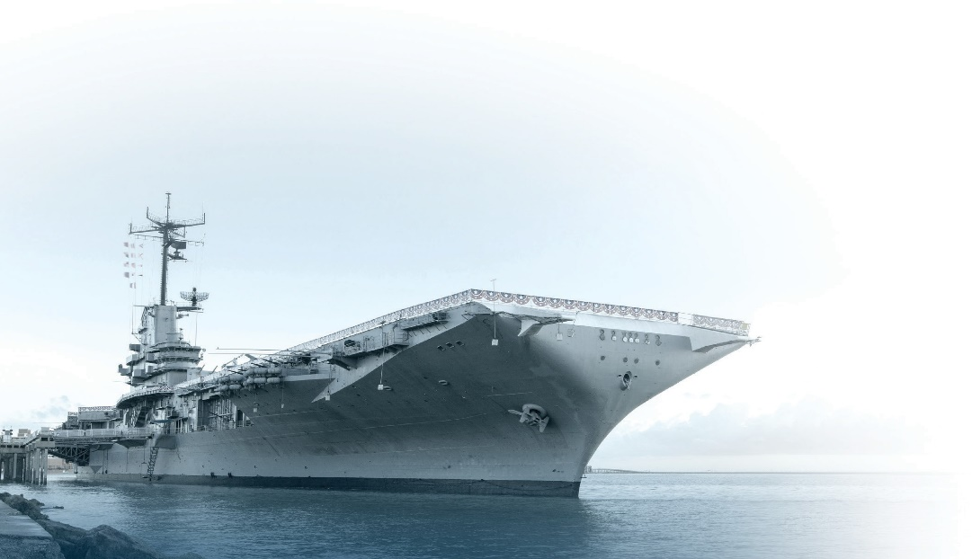
Tickets can be purchased now at www.usslexington.com. Individual tickets are $65, couples tickets are $95, and reserved tables for 10 are $800. Sponsorships of varying levels are also available. Proceeds from this fundraising event will support continued restoration and maintenance of the USS Lexington Museum.
NATIONAL HISTORIC LANDMARK

WHAT: 31st Annual Stage Door Canteen

WHERE: USS Lexington Museum, 2914 N. Shoreline Blvd.

WHEN: Friday, February 16, 2024, 7:00-10:00 p.m.

###

