P.O. BOX 23076 | 2914 NORTH SHORELINE BOULEVARD | CORPUS CHRISTI, TX 78403 | P 361-888-4873 | F 361-883-7589 | 800-LADY LEX | USSLEXINGTON.COM

PRESS ADVISORY

FOR IMMEDIATE RELEASE For More Information Contact:
December 5, 2023 Blakely Millsaps
361.888.4873 Ext. 306

DECEMBER 7th . . . 82 YEARS AGO

CORPUS CHRISTI - The USS Lexington Museum will hold a Remembrance Ceremony on Thursday, 7 December, 2023, at 2:00 p.m. to commemorate the 82nd anniversary of the 1941 surprise attack on Pearl Harbor. The ceremony, which will honor those who died in the attack, will feature the Corpus Christi Veterans Band, Mary Carroll High School NJROTC members, and the Corpus Christi Pipes & Drums. The National Anthem will be sung by Mick Boudreau. In Navy tradition, a wreath will be laid in the water followed by Taps.

The ceremony is sponsored by the USS Lexington Volunteer Organization and will be hosted by CAPT Steve Banta, USN (Ret.), Executive Director, USS Lexington Museum.

Following the ceremony, with his family in attendance, we will pay tribute to the late CAPT Bob Batterson, former USS Lexington Museum Volunteer and Pearl Harbor survivor. As an addition to the Pearl Harbor exhibit, where he would share his story with guests during his time as a LEX Volunteer, Bob has been immortalized through the use of cutting-edge holographic technology* that enables him to continue vividly narrating his account of what transpired during the attack on Pearl Harbor.

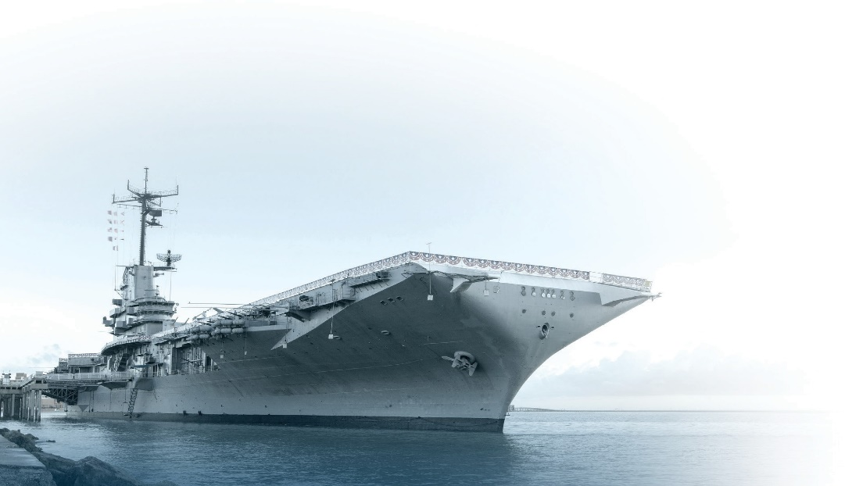
Admission and parking for this event is complimentary.
NATIONAL HISTORIC LANDMARK

*Media is advised to reduce shutter speed to 1/24 frames per second or slower in order to record hologram video.

WHAT: Pearl Harbor Day Remembrance Ceremony

WHERE: USS Lexington Museum, 2914 N. Shoreline Blvd.

WHEN: Thursday, December 7, 2023 2:00 PM

###

